DATES FOR THE DIARY
TUESDAY 29th JUNE – School finishes for the summer break at the following times:
P.5,6 12:00
P.4 12:15
P.3 12:30
P.2 12:45
Nursery 1:00
P.1 1:10
Children will leave through their usual exits. Please do not ask for older children to get out earlier with younger siblings as this will not be possible.
WEDNESDAY 25TH AUGUST - SCHOOL RE-OPENS
Nursery and P1 children start Tuesday 24th August (in small groups - please see Seesaw/Induction Pack for your child’s start date/days)

COACHING FOR CHRIST FUN DAY
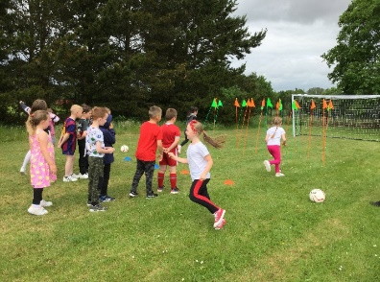
All of the children had a fantastic day of fun and football. Thank you to everyone who contributed, we raised a brilliant £707.00 for this charity!

ARRANGEMENTS FOR THE OPERATION OF THE SCHOOL NEXT YEAR
Guidance on how schools are to operate in the next school year has not been issued, so as yet we don’t know if classes are to operate in bubbles. All arrangements, including those for coming in and going home, breakfast club, starting and finishing times etc will be sent to you in August. Thank you to everyone for your patience, flexibility and adapting so well to the changes that had to be made this year.
The staff team hope that everyone has a lovely summer.

SCHOOL UNIFORM
A reminder that school uniform is now on sale at Wallace. Please also remember that when buying footwear, it is black leather shoes for ALL children. P.4 to P.7 can change their shoes at break and lunchtimes if playing football. Dark grey or black socks for boys and grey socks, white socks or grey tights for girls.

FINAL DAYS IN P7
The children in P7 had a great time during their final few days in Ballykeel. They enjoyed some fabulous inflatable fun a picnic out on the grass!
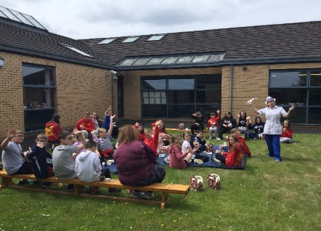

AR MILLIONNAIRES
Congratulations to Jesse and Eva in P6JF who have recently found out that they are AR reading Millionaires! They join with Olaf in
celebrating this super achievement.
Well done to all 3 children in P6JF!
PUPILS OF THE MONTH – June 2021
P1CC - Joel
P1KM - Jaxon
P2JT - Andrew
P2AM - Rio
P3CM - Thomas
P3LK - Klara
P4KH - Leah
P4JDT - Abigail
P5BE - Tate
P5MA - Jack
P6JF - Rebekkah
P6SM - Eloise

