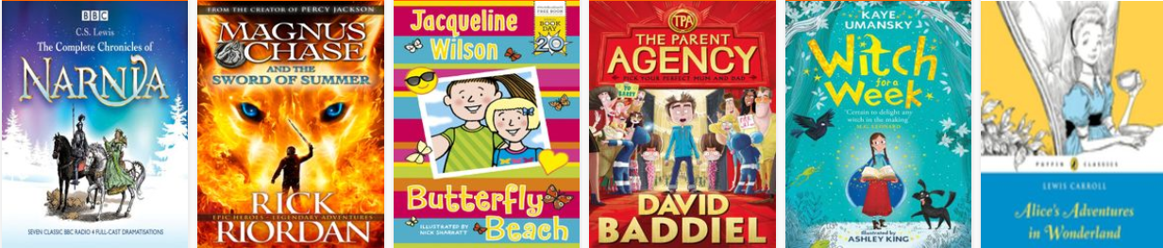

Google : NI Libraries or go straight to the website: https://www.librariesni.org.uk/Pages/eBooks.aspx
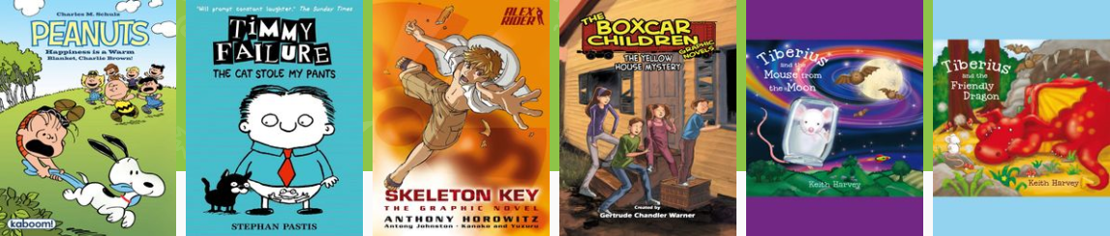
And follow the instructions to join.
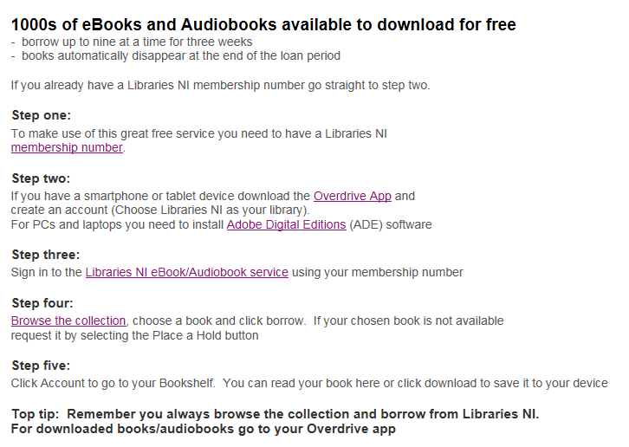
Note: This is not available for use in a school setting, only for personal use.

